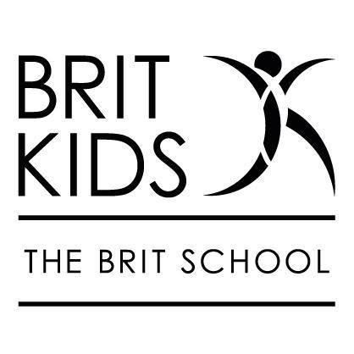
BRIT Kids Relationship Management Policy
Aims:
• Students will be encouraged to develop positive behaviour for learning, creating and performing.
▪ To provide a safe, supportive, happy and welcoming community which encourages each individual to achieve their own potential through a desire for individuality and creativity.
▪ To enable staff to support children with their behaviour through providing students with strategies to manage their own behaviour.
▪ To maintain a calm and purposeful working atmosphere.
▪ To ensure that all children and adults have a sense of belonging, feeling safe, secure and valued.
▪ To provide a clear, fair and consistent approach to behaviour.
General behaviour issues should be dealt with in lesson by the teacher. If there are recurring issues a manager will be informed and parents/guardians will be communicated with and a plan put in place to support the child. If needed a manager can remove the child from the class.
If child is removed from class:
Action: Manager/Director to call parent/guardian and arrange meeting to discuss problems and solutions. This should be logged with the Director and, if thought fit, issue a final warning, a letter stating this will also be issued by the Director. A final warning will remain active for a year.
If the issue continues despite support put in place.
Action: Student asked to leave Brit Kids by letter, which should offer a meeting so that the decision can be explained to them (NOT discussed).
Stages may be missed out in the event of serious misconduct. Examples may include bullying, swearing, leaving campus without authority, violence, stealing, and threats.

